Software Requirements Specifications

**Garden Vision AR**

# Project Code:

**CMPC-401**

# Internal Advisor:

Mr. Mudassir Ali Zaidi

# External Advisor:

Mr. Nabeel Tariq

# Project Manager:

Dr. Muhammad Ilyas

# Project Team:

Abdul Jabbar (BSCS51F20S049RE)

Muhammad Talha Saeed (BSCS51F20S003) Qais Ali (BSCS51F21S066)

# Submission Date:

26-11-2024

# Document Information

|  |  |
| --- | --- |
| **Category** | **Information** |
| Customer | University Of Sargodha |
| Project | Garden Vision AR |
| Document | Requirement Specifications |
| Document Version | 1.0 |
| Identifier | PGBH01-2003-RS |
| Status | Draft |
| Author(s) | Abdul Jabbar  Muhammad Talha Saeed Qais Ali |
| Approver(s) | PM |
| Issue Date | November 24,2024 |
| Document Location |  |
| Distribution | 1. Advisor 2. PM 3. Project Office |

**Definition of Terms, Acronyms and Abbreviations**

|  |  |
| --- | --- |
| **Term** | **Description** |
| RBAC | Role-Based Access Control |
| AR | Augmented Reality |
| SSL/TLS | Secure Sockets Layer / Transport Layer Security |
| SDK | Software Development Kit |
| GDPR | General Data Protection Regulation |
| DBMS | Database Management System |
| FAQ | Frequently Asked Questions |
| API | Application Programming Interface |
| UAT | User Acceptance Testing |
| SEO  14 | Search Engine Optimization |

# Table of Contents

1. [INTRODUCTION 8](https://docs.google.com/document/d/1N6IF2LgZ6JALAOsTN6gUHccZHiSw4t6U6E11SG2CKHA/edit#heading%3Dh.49x2ik5)
   1. [Purpose of Document 8](https://docs.google.com/document/d/1N6IF2LgZ6JALAOsTN6gUHccZHiSw4t6U6E11SG2CKHA/edit#heading%3Dh.3znysh7)
   2. [Project Overview 8](https://docs.google.com/document/d/1N6IF2LgZ6JALAOsTN6gUHccZHiSw4t6U6E11SG2CKHA/edit#heading%3Dh.2p2csry)
   3. [Scope 8](https://docs.google.com/document/d/1N6IF2LgZ6JALAOsTN6gUHccZHiSw4t6U6E11SG2CKHA/edit#heading%3Dh.tyjcwt)
2. [OVERALL SYSTEM DESCRIPTION 9](https://docs.google.com/document/d/1N6IF2LgZ6JALAOsTN6gUHccZHiSw4t6U6E11SG2CKHA/edit#heading%3Dh.147n2zr)
   1. [User characteristics 9](https://docs.google.com/document/d/1N6IF2LgZ6JALAOsTN6gUHccZHiSw4t6U6E11SG2CKHA/edit#heading%3Dh.3o7alnk)
   2. [Operating environment 9](https://docs.google.com/document/d/1N6IF2LgZ6JALAOsTN6gUHccZHiSw4t6U6E11SG2CKHA/edit#heading%3Dh.23ckvvd)
   3. [System constraints 9](https://docs.google.com/document/d/1N6IF2LgZ6JALAOsTN6gUHccZHiSw4t6U6E11SG2CKHA/edit#heading%3Dh.17dp8vu)
3. [EXTERNAL INTERFACE REQUIREMENTS 10](https://docs.google.com/document/d/1N6IF2LgZ6JALAOsTN6gUHccZHiSw4t6U6E11SG2CKHA/edit#heading%3Dh.ihv636)
   1. [Hardware Interfaces 10](https://docs.google.com/document/d/1N6IF2LgZ6JALAOsTN6gUHccZHiSw4t6U6E11SG2CKHA/edit#heading%3Dh.lnxbz9)
   2. [Software Interfaces 10](https://docs.google.com/document/d/1N6IF2LgZ6JALAOsTN6gUHccZHiSw4t6U6E11SG2CKHA/edit#heading%3Dh.35nkun2)
   3. [Communications Interfaces 10](https://docs.google.com/document/d/1N6IF2LgZ6JALAOsTN6gUHccZHiSw4t6U6E11SG2CKHA/edit#heading%3Dh.1ksv4uv)
4. [FUNCTIONAL REQUIREMENTS 10](https://docs.google.com/document/d/1N6IF2LgZ6JALAOsTN6gUHccZHiSw4t6U6E11SG2CKHA/edit#heading%3Dh.44sinio)
5. [NON-FUNCTIONAL REQUIREMENTS 11](https://docs.google.com/document/d/1N6IF2LgZ6JALAOsTN6gUHccZHiSw4t6U6E11SG2CKHA/edit#heading%3Dh.2jxsxqh)
   1. [Performance Requirements 11](https://docs.google.com/document/d/1N6IF2LgZ6JALAOsTN6gUHccZHiSw4t6U6E11SG2CKHA/edit#heading%3Dh.z337ya)
   2. [Safety Requirements 11](https://docs.google.com/document/d/1N6IF2LgZ6JALAOsTN6gUHccZHiSw4t6U6E11SG2CKHA/edit#heading%3Dh.3j2qqm3)
   3. [Security Requirements 11](https://docs.google.com/document/d/1N6IF2LgZ6JALAOsTN6gUHccZHiSw4t6U6E11SG2CKHA/edit#heading%3Dh.1y810tw)
   4. [User Documentation 12](https://docs.google.com/document/d/1N6IF2LgZ6JALAOsTN6gUHccZHiSw4t6U6E11SG2CKHA/edit#heading%3Dh.3whwml4)
6. [ASSUMPTIONS AND DEPENDENCIES 12](https://docs.google.com/document/d/1N6IF2LgZ6JALAOsTN6gUHccZHiSw4t6U6E11SG2CKHA/edit#heading%3Dh.32hioqz)
7. [REFERENCES 14](https://docs.google.com/document/d/1N6IF2LgZ6JALAOsTN6gUHccZHiSw4t6U6E11SG2CKHA/edit#heading%3Dh.qsh70q)
8. [APPENDICES 15](https://docs.google.com/document/d/1N6IF2LgZ6JALAOsTN6gUHccZHiSw4t6U6E11SG2CKHA/edit#heading%3Dh.3as4poj)

# Introduction

# Purpose of Document

This document presents the software requirements of the project “Garden vision AR”. It gives a detailed explanation on how the system is supposed to work, its limitations and how it is expected to perform. Audience covers the project stakeholders, developers, testers and the project managers. The document is used to maintain a clear understanding of the project needs that will help in the developmental as well as the testing phase. It is also used to confirm that the characteristic of the final product is sufficient to fulfill the needs of the users, the capacities of the system and the legal requirements. This SRS will be updated from time to time according to the scope or the required changes during its life cycle of the project.

# Project Overview

The “Garden vision AR” is an AR project implemented on a web page that can help buyer select plants and offer care instructions for them. It has augmented reality elements for visualizing the plants into user spaces and has expert gardening services. The goal of the project is to improve gardening differently by having a simple and easy to use front-end, garden experts and engaging tools. The app offers the users plant variety, individualized guide to plant caring and the community support in case of new garden users. The platform includes safe payment methods and instant customer care service to provide the buyer with a meaningful and simple purchasing. Also, the AR capability enables people to visualize plants in their environments and makes better purchasing choices while enhancing environmentally friendly spaces.

# Scope

Users can persue vegetation items through the platform, make purchases, and get tips on how to maintain the plants. It will also offer AR visualizations, get advice from experts, and share on social networking websites and platforms. Also, users can ask some questions concerning gardening to practitioners and even share their experiences with other users. It performs a useful function as a platform that is excited about innovations in garden and plant care from a sustainable perspective. It does not provide same-day order delivery tracking or in-app

customer-to-customer messaging, but it concentrates on a perfect shopping experience and realistic plant visualization.

# Overall System Description

# User characteristics

* + - **Regular Users:** Persons interested in gardening with different level of experience, aiming at buying plants
    - and access care guides.
    - **Guest Users:** Allows patrons to only search the catalog for items which can be borrowed.
    - **Registered Users:** Orders tracking feature, and using Augmented Reality application fully.
    - **Admin Users:** Upon completing this module, the trainee will be able to: Create, update, and remove products, users, and content for the Online Store Platform.

# Operating environment

It runs on WWW browsers, and actual augmented reality depends upon an active Internet connection. The requirement for the AR application is that it should be compatible with standard mobile devices and operating systems.

# System constraints

* + - **Software Constraints:** Here, the platform solely depends on the Augmented Reality Software Development Kits that include Vuforia or ARCore. can have limitations that are caused by compatibility with certain devices or by an updated version or hardware requirements.
    - **Hardware Constraints:** All of these augmented reality features are only capable on a device that has built-in AR capabilities.
    - **Security Constraints:** Data security to protect the user’s details that would normally be inputted into the site such as phone, address and credit card information.
    - **Environmental Constraints:** Some limitations in terms of functionality when used in low light applications such as AR.
    - **Legal Constraints:** It is observed that the organization under discussion is compliant with the data protection laws and available privacy regulations.

# External Interface Requirements

# Hardware Interfaces

Supports Camera input devices for Augmented Reality rendering. Device compatibility encompasses mobile devices effective for the functioning of AR applications.

# Software Interfaces

* + - **Operating System:** On the operating system’s Front-end, it will be Windows and Android for the AR application.
    - **Databases:** MySQL for user data storage.
    - **Web Technologies:** HTML and or CSS for the User interface and JavaScript as well as PHP for the User interface.

# Communications Interfaces

The platform relies on secure HTTPS communication protocols for data transmission. Payment information is encrypted, and multi-factor authentication ensures secure access.

# Functional Requirements

**User Registration and Login**: Users can register, login, and access platform features.

**Product Catalog**: A categorized display of plants and fertilizers.

**AR Visualization**: Allows users to visualize plants in their spaces via an AR app. **Shopping Cart**: Users can add items to a cart, review, and proceed to checkout. **Order Tracking**: Users can view order status updates.

**Feedback and Reviews**: Users can submit product reviews and feedback.

**Feedback and Reviews**: Users can submit product reviews and feedback

# Non-functional Requirements

# Performance Requirements

System response time under 2 seconds for standard interactions. Capable of supporting 1,000 concurrent users without degradation

# Safety Requirements

AR visualization to be restricted in low-light conditions for accuracy Clear error handling to prevent data loss during interactions.

# Security Requirements

Multi-factor authentication for access

Data encryption for personal and payment information

Role-based access control (RBAC) for admins and users.

# User Documentation

User manual for plant browsing, shopping cart, and AR app use. Online tutorials and FAQs.

# Assumptions and Dependencies

* 1. **Assumptions**

# User Device Compatibility:

Assumes users possess devices compatible with augmented reality (AR) functionalities, particularly for mobile devices with adequate camera quality and processing power to handle AR rendering.

# Internet Connectivity:

Assumes that users will have stable internet access, as many functionalities, including AR streaming, database access, and real-time interactions, require reliable internet connections.

# User Familiarity with Digital Transactions:

Assumes users are comfortable with online payments and familiar with e-payment systems like Easy paisa and Jazz Cash, as the platform relies on digital transactions for processing purchases.

# Platform Scalability:

Assumes that the backend infrastructure, including databases and server resources, can scale horizontally to meet potential user growth and demand fluctuations, especially during peak seasons like spring and summer.

# User Privacy Compliance:

Assumes the platform complies with privacy regulations relevant to the regions it serves (such as GDPR for European users) to ensure secure handling of user data and avoid legal constraints.

# Dependencies

* + - **AR Technology and SDKs**:

Relies on the availability of updated AR software development kits (SDKs), such as Vuforia or AR Core, which support augmented reality features. Any updates or changes to these SDKs could affect AR app functionality.

* **Payment Gateway Integration:**

Fully dependent on third party payment gateways of Easy paisa and Jazz Cash for processing the transactions. Concerning the APIs, availability and the transaction fees of these systems, modifications to them may affect the user transactions and the cost of running the platform directly.

* **Database Management System:**

Uses MySQL as its database platform that will be used to store the data obtained. Because MySQL serves as a database of user information as well as a product catalog and transaction record, problems that arise from MySQL may affect the platform’s performance or stability.

* **Third-Party Security Services:**

All of the web-based application and products rely on security services like SSL/TLS encryption for secure data or providers of multi-factor authentication to secure the users. In addition, new innovation in these or security protocol updates, may so dictate alteration of the system.

# External Libraries and Frameworks:

Complementary with JavaScript libraries, PHP frameworks and other auxiliary libraries used for development of the front part and backend. These libraries might need an update on their codes because of updates or deprecations of the libraries.

# User Feedback and Community Engagement:

Envisages that users will come forward to provide feedback on the platform through rating and coming to the support section to provide feedback to make further enhancements and feature modification due to real-world users’ needs.

# References

|  |  |  |  |
| --- | --- | --- | --- |
| **Ref. No.** | **Document Title** | **Date of Release/**  **Publication** | **Document Source** |
| 7.1 | EEE Std 830-1998:  Recommended Practice for Software  Requirements  Specifications | 1998 | IEEE Standards Association |
| 7.2 | MySQL 8.0  Reference Manual | Current Version | MySQL  Documentation [https://dev.mysql.com](https://dev.mysql.com/doc/)  [/doc/](https://dev.mysql.com/doc/) |
| 7.3 | Vuforia SDK Developer Guide | Current Version | Vuforia Developer Library https://library.vuforia. com/ |
| 7.4 | GDPR Compliance Guide | May 2018 | European Union  GDPR Portal <https://gdpr-info.eu/> |
| 7.5 | Easy paisa and Jazz Cash Payment Integration APIs | Current Version | Easy paisa and Jazz Cash Developer Documentation |

**Appendices**

# Appendix A: Glossary of Terms

Defines key terms, acronyms, and abbreviations used within the SRS document to ensure consistent understanding among stakeholders.

* + - **AR**: Augmented Reality - Technology enabling real-world visualizations of virtual objects.
    - **RBAC**: Role-Based Access Control - A method for managing user permissions based on roles.
    - **SSL/TLS**: Secure Sockets Layer / Transport Layer Security - Protocols for securing internet communication.

# Appendix B: Use Case Scenarios

Outlines specific use cases to clarify typical interactions and functionalities of the system for users and developers.

* + - **Use Case - User Registration and Login**: Details steps for new users to register and log in to access platform features.
    - **Use Case - AR Visualization of Plants**: Describes steps for using the AR app to visualize plants within the user’s physical environment.
    - **Use Case - Order Placement and Tracking**: Provides a flow of actions from product selection, checkout, payment, and tracking order status.

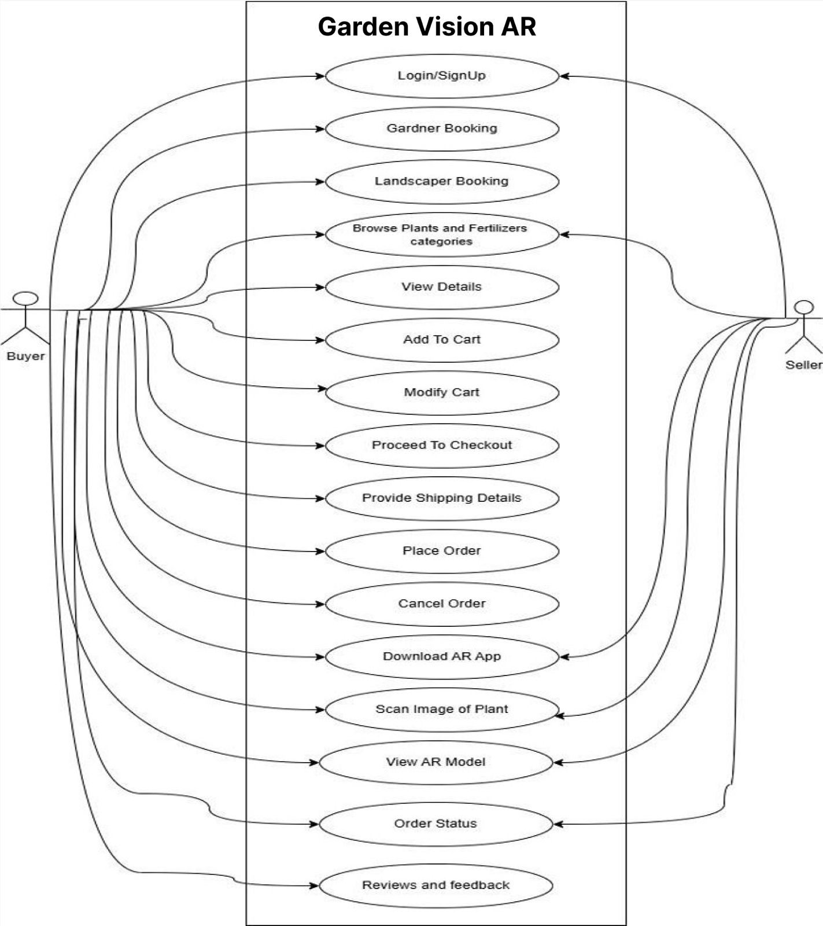

# Appendix C: Sequence Diagram

Presents a high-level Sequence Diagram to illustrate data movement and interaction between major system components, including:

* **User Browses Products**: The user views the product catalog, and the frontend fetches product data from the backend and database.
* **AR Visualization**: The user selects a plant and visualizes it in their space using the AR feature, facilitated by the backend.
* **Add to Cart**: The user adds the plant to their cart, and the backend updates the cart data in the database.
* **Place Order**: The user proceeds to checkout and confirms the order.
* **Payment Processing**: The backend processes the payment via a secure payment gateway.

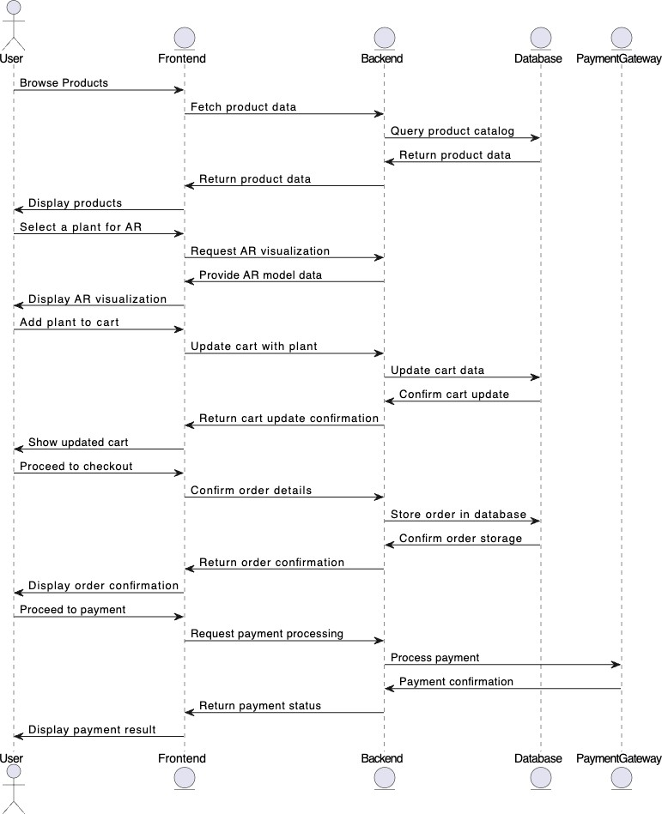

# Appendix D: User Interface Mockups

Provides visual representations of the main screens of the Green World platform, such as:

* + - **Home Screen**: Initial user interface, highlighting search, categories, and main navigation.
    - **Product Detail Screen:** Sharing information about each plant or product, including how to take care of it, and where to buy it.
    - **AR Model Screen:** Likewise, shows how users can tell where specific plants can go in spaces with the help of the AR app.

# Appendix E: Testing Protocols and Test Cases

* + - **Unit Testing:** Checking specific functionalities, like the ability to log in, to search and to add a product to the cart.
    - **Integration Testing:** They help to insulate other components of functionality – for instance, payment, and AR visualization, so they flow cohesively.
    - **User Acceptance Testing (UAT):** They guarantee that the platform allows users to have achievable expectations in terms of easy use, quick access and effective performance.

# Appendix F: Hardware and Software Requirements

Specifies the minimum hardware and software requirements necessary for users to effectively utilize the platform:

* + - **Hardware:** The minimum requirements of a mobile device required for augmented reality, in terms of camera and operational performance.
    - **Software:** Minimum necessary iOS version is 13 and Android version is 8+ required browsers for Web interface.

# Appendix G: Risk Assessment and Mitigation Strategies

Details potential risks, their impacts, and mitigation strategies, such as:

* + - **Risk:** User data breaches – Control: To reduce the risk, user data should be encrypted using Secure Socket Layer/Secure Transport Layer Security and a security audit done regularly.
    - **Risk:** Reliance on third-party payment platforms – Control: Adapt and plan for emergencies to have other forms of payment.